CASE STUDY ON SMART WATCH

INTRODUCTION:

A smartwatch is a wearable computer in the form of a watch; modern smartwatches provide a local touchscreen interface for daily use, while an associated smartphone app provides for management and telemetry. It is very comfort and easy to use.

FEATURES:

Arduino board is a micro-processor and a storage, and there’s only one input method : a button.

Bluetooth is to communicate with other devices, and the battery would be necessary for power.

I’ll install an Android app for collecting or editing various RSS and system information and

for notification on the Android device.

REQUIREMENT: Hardware parts for smart watch

Arduino micro-controller

Bluetooth

Display

Battery wires, soldering iron, a switch and 10K ohm resistance(for a button), and a batter jack.

Preparing for Android

Other components may be included like temperature sensor, motion sensor,etc,..

COMPONENTS

TEMPERATURE SENSOR

Temperature sensor is a device, used to measure the temperature using an electrical signal.

MOTION SENSOR

A motion sensor is a device that notices moving objects, mainly people.It is used to count steps of an individual.

HEART BEAT SENSOR

The Heart Beat Sensor provides a simple way to study the heart's function.

REAL TIME CLOCK

A real-time clock ( RTC) is a computer clock is most often in the form of an integrated circuit that keeps track of the current time

LED DISPLAY

A LED display is a flat panel display that uses an array of light-emitting diodes as pixels for a video display.

GSM MODEM

A GSM modem is a specialized type of modem which accepts a SIM card, and operates over a subscription to a mobile operator, just like a mobile phone.

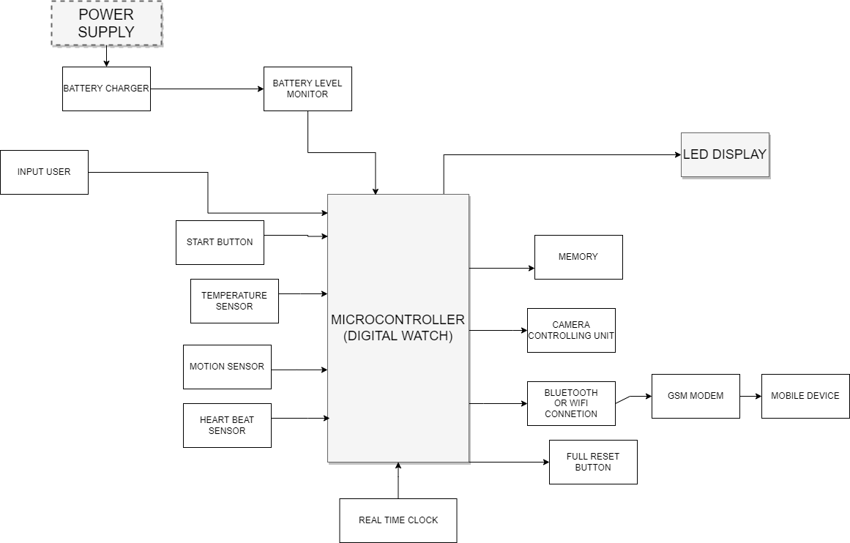

APPLICATIONS

Initial display:

The phase which the logo shows up when the watch boots.

Clock display:

The basic display which tells you time. You can change the style of the clock in the Android app. Analog, Digital, Mixed styles are supported so far. If you push the button, the display changes to the Emergency message display. It changes to the idle mode in case there’s no data update for 10 minutes.

Emergency message display:

The display that shows when users push the button in the watch display or a new emergency message is updated. If users push the button again or 10 seconds passes, the next message is shown. The display changes to a the normal message display after every emergency message shows.

Normal message display:

The display that shows after emergency message ends or users push the button. The next message shows up when users push the button or after 5 seconds. The display changes to the clock when the last message shows.

Idle display:

The display that is shown if there’s no data push during 10 minutes. It displays Indicator and time(hh:mm) the display update interval changes to run at minimum power consumption. If you push the button or get a new message, the display changes to the clock display.